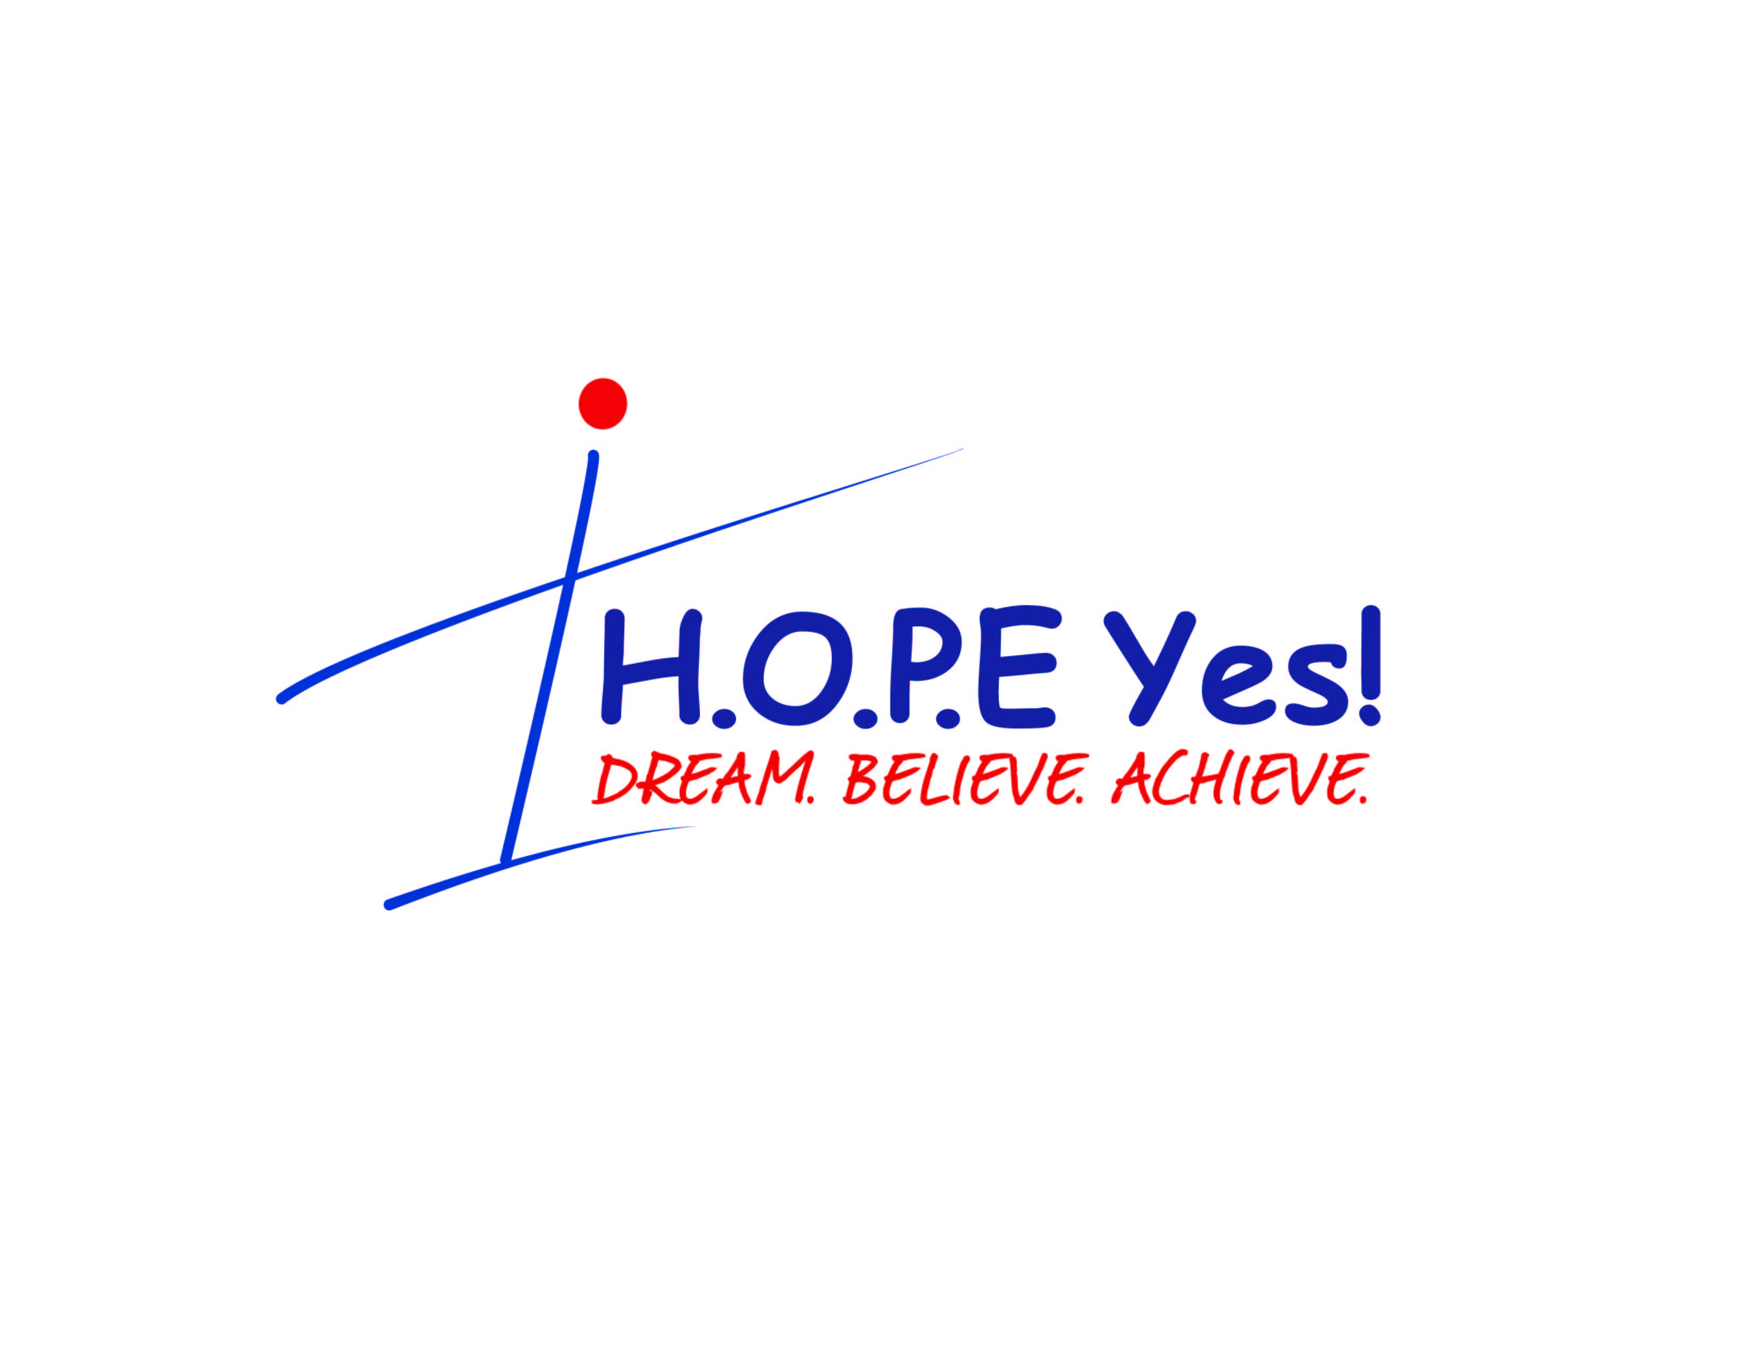

**H.O.P.E. Yes!** is a one day summer enrichment opportunity geared towards underrepresented (URM) elementary, middle and high school students to develop interest in the fields of health sciences with a major focus on dentistry. This program also seeks to provide leadership and mentorship opportunities for its participants. Both objectives are carried out through a series of creative workshops and exciting hands on experiments.

**H.O.P.E. Yes!** will be an all day experience conducted on Saturday, June 2nd on the campus of Howard University in the College of Dentistry.

**Objectives of H.O.P.E. Yes!**

This one day experience will allow the participant:

* To be exposed to careers within the health sciences with a major focus on dentistry.
* To pipeline students into the Summer Medical and Dental Enrichment Program (SMDEP).
* To foster confidence and leadership abilities.
* To better define the professional role of health science professionals.
* To engage in interactive dental and allied dental health experience through hands on laboratory experiments

**Please be mindful that all applications MUST be postmarked or emailed by May 24, 2019 to:**

Mail application and other required information to: **Howard University College of Dentistry**

**Dept. of Pediatric Dentistry**

**Attention: Dr. LaToya Barham, H.O.P.E. Yes!**

**Second Floor, Suite 221**

**600 “W” Street, N.W.**

**Washington, DC 20059**

[*latoya.barham@howard.edu*](mailto:latoya.barham@howard.edu)

*or*

[*k_marshall@howard.edu*](mailto:k_marshall@howard.edu)



**H.O.P.E. Yes!** *Dream. Believe. Achieve.*

**2019 Summer Enrichment Program**

for

**Elementary School Middle School High School**

**(3rd- 5th Grade)**

**June 8, 2019 June 8, 2019 June 8, 2019**

**Howard University College of Dentistry**

**Russell B. Dixon Building**

**600 “W” Street, N.W.**

**Washington, DC 20059**

LaToya M. Barham, DDS, Assistant Professor, Department of Pediatric Dentistry  
[latoya.barham@howard.edu](mailto:latoya.barham@howard.edu) office 202-806-0003

Kathy L. Marshall, DDS , Assistant Professor, Department of Orthodontics  
[k_marshall@howard.edu](mailto:k_marshall@howard.edu%20)  office 202-806-0015

This program was made possible by the Minority Dental Faculty Development Grant sponsored by the **W.K. Kellogg Foundation** through the **American Dental Education Association (ADEA) and Howard University College of Dentistry.**

**H.O.P.E. Yes!** *Dream. Believe. Achieve.*

**2019 Summer Enrichment Program**

**Elementary School Middle School High School**

**(3rd- 5th Grade)**

**June 8, 2019 June 8, 2019 June 8, 2019**

**APPLICATION PROCEDURES**

1. Complete the application form as directed.
2. All information requested MUST be received by **May 24, 2019 via mail or email to:**

Mail application and other required information to: **Howard University College of Dentistry**

**Dept. of Pediatric Dentistry**

**Attention: Dr. LaToya Barham, H.O.P.E. Yes!**

**Second Floor, Suite 221**

**600 “W” Street, N.W.**

**Washington, DC 20059**

[latoya.barham@howard.edu](mailto:latoya.barham@howard.edu)

or

[*k_marshall@howard.edu*](mailto:k_marshall@howard.edu)

Late applications will not be accepted. Notification of acceptance should occur after May 24, 2019.

The program will be held on Saturday, June 8, 2019. There is no application fee or tuition for this program.

This program was made possible by the Minority Dental Faculty Development Grant sponsored by the **W.K. Kellogg Foundation** through the **American Dental Education Association (ADEA)** and **Howard University College of Dentistry.**

LaToya M. Barham, DDS, Assistant Professor, Department of Pediatric Dentistry  
[latoya.barham@howard.edu](mailto:latoya.barham@howard.edu) office 202-806-0003

Kathy L. Marshall, DDS , Assistant Professor, Department of Orthodontics  
[k_marshall@howard.edu](mailto:k_marshall@howard.edu) office 202-806-0015



**H.O.P.E. Yes!** *Dream. Believe. Achieve.*

**2019 Summer Enrichment Program**

**STUDENT’S NAME:**

Last First Middle

**CHECK THE SESSION YOU WISH TO ATTEND**:

* **Elementary(3rd-5th Grade)** June 8, 2019
* **Middle School** June 8, 2019
* **High School** June 8, 2019

**CURRENT SCHOOL 2018-2019:______________________________________Current Grade:_________**

**Gender: Date of Birth:**

* Male **________________________________**
* Female month/day/year

**Parent’s / Court Appointed Legal Guardian’s Name and Address:**

Mr./Mrs. /Ms. First Last

Street Address Apt. No.

City, State, Zip Email

Contact Phone **Parent / Guardian Signature Date**

This application must include:

1. **Teacher Evaluation** –the attached checklist for the correct grade should be completed, including teacher’s name.
2. **Other Recommendation**- the attached checklist for the correct grade should be completed, including recommender’s name and relationship to student (ie. principal, coach, counselor).
3. **Personal Statement** (Middle and High School only).

 **H.O.P.E. Yes!** *Dream. Believe. Achieve.*

**STUDENT EVALUATION**

**Phase III – May 24, 2019**

**Grades 9-12 High School Criteria**

• URM male or female

• Economic need

* **Teacher evaluation**

• **1 letter of recommendation**; one letter must be from a community leader or administrator

• **Personal Statement**: “What is important in life to me”

This statement can either be essay (300 words) or creative presentation (3-5minutes); no vulgarity, please, and it must be original work.

**Name of Applicant:** (please print or type)

__________________________________________________________________________________

(Last) (First) (Middle)

**Name of Evaluator:** (please print or type)

__________________________________________________________________________________

(Last) (First) (Middle)

**How do you know the applicant?:**

Teacher Principal Counselor Other (please specify)_________________________

**Please summarize your evaluation by checking one of the following terms: (Exceptional, Average, Poor** or **Not Applicable [N/A])**

• Classroom behavior/maturity: Exceptional Average Poor N/A

• Attentiveness: Exceptional Average Poor N/A

• Verbal communication skills: Exceptional Average Poor N/A

• Written communication skills: Exceptional Average Poor N/A

• Works well with others: Exceptional Average Poor N/A

• Creative ability (curiosity/dexterity/skills/talents): Exceptional Average Poor N/A

• Works well independently: Exceptional Average Poor N/A

• Leadership ability: Exceptional Average Poor N/A

**Any other comments:** (Applicants area of greatest strength and/or areas needing improvement)